QC Devils Order form
Players Name |  | Age |  | Team (if known)
Parent Name | Phone Number |  | Email
Parent Name | Phone Number |  | Email
Jerseys will not be ordered until payment is received. NO EXCEPTIONS.
Limited jersey order will be processed through the year.
Jersey numbers are not guaranteed.
Item | Size | 1st choice Jersey Number | 2nd choice Jersey Number | Price
Item A black/maroon hat
Item B grey hat
Item C black/pink hat
Item D black jersey
Item E maroon jersey
Item F camo jersey
Item G black/pink jersey
Start Up fees | Insurance, Registration and 501c |  |  | $55.00
Window Decal $10 | ------------------------------
Helmet Decal $3 | ------------------------------

Total

QC Devils Order form
Item C
Black/ pink Flexfit Mesh QC pink logo w/white border
$20 each
Sizes: S/M (6 3/4-7 1/4) and L/XL (7 1/8-7 5/8)

Item B
Grey Flexfit with QC logo white w/black border.
$20 each
Sizes: Youth (6.5" -7), S/M (6 3/4" - 7 1/4") - L/XL (7 1/8" - 7 5/8")
Item A
Black/ maroon hat Flexfit Mesh QC logo maroon w/gold border
$20 each
Sizes: S/M (6 3/4-7 1/4) and L/XL (7 1/8-7 5/8)

Available for parents.

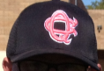
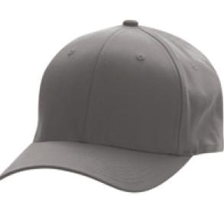
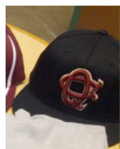

Players Only

Item E
Maroon Crossbow 1232/ 1202P
Size: Youth S-L $40, Adult S-XL $40, 2XL $42 and 3XL $44 (coaches only)

Item D
Black Badger B- core #2120
Size: Youth XS-XL, Adult S-XL$20, 2XL $22 and 3XL $24, Ladies S XL $20 and 2XL $22

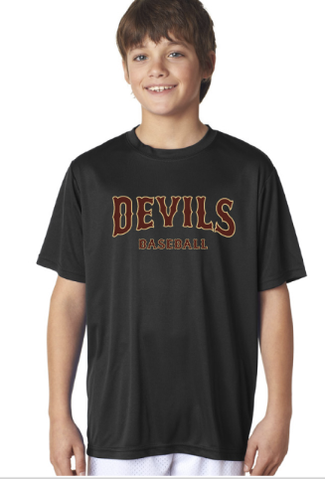
Jersey available for parents, no jersey number.
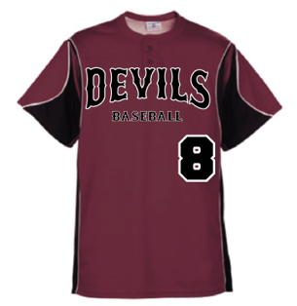
Players only

Item G
Black A4 Black jersey – Pink lettering (October)
Size: Youth XS-L $20, Adult S-XL $20, 2XL $22, 3XL $24 and 4XL $26 (coaches only)
……………………………………………………………………

Item F
Charcoal Badger digi camo accent # 2140
Size: Youth XS-L $25, Adult S-XL $25, 2XL $27, 3XL $29 and 4XL $31 (coaches only)
……………………………………………………………………

